YouHeaL Analysis
Dom Grisafe
2019-10-01

Timeline
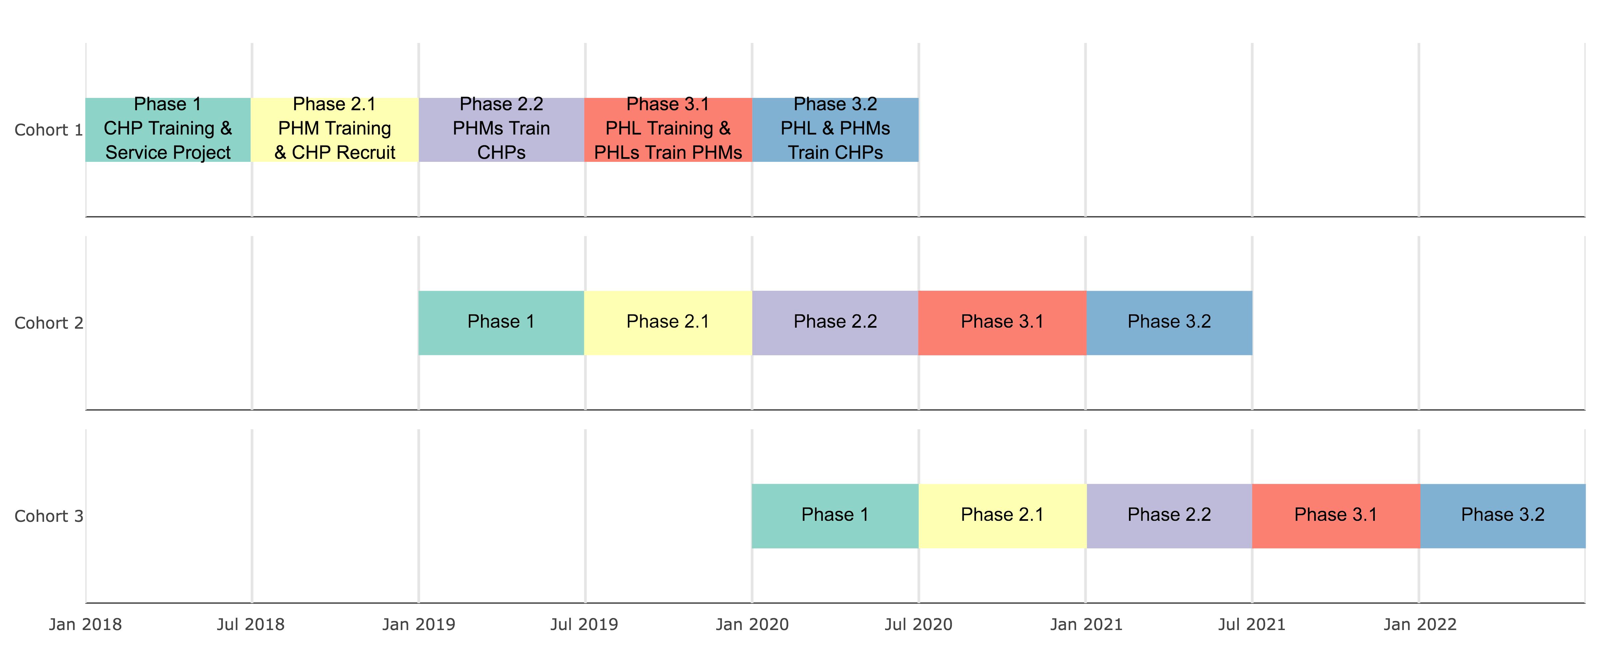
The image shows the expected timeline of the YouHeaL study. The study is designed to have 3 cohorts that each begin one year apart.
During the first 6 months the first cohort is trained as Community Health Promoters (CHP) and completes a service project. The second 6 months, they are trained as Peer Health Mentors (PHM), where they learn to train their classmates to be CHPs. During the third 6 month period, Cohort 1 become PHMs that train Cohort 2 to be CHPs. At this point Cohort 2 begins doing everything Cohort 1 started, but 1 year behind them. During the fourth 6 month period, Cohort 1 is trained as Peer Health Leaders (PHL), where they learn to train the CHPs to become PHMs for Cohort 3, and then PHLs from Cohort 1 actually train Cohort 2 to be PHMs. Finally, during the fifth 6 month period, the PHLs from Cohort 1 work with the PHMs from Cohort 2 to train Cohort 3 to be CHPs.
Each cohort is larger than the last, propagating healthy lifestyle habits to increasingly larger groups of high school students through their social networks.

Data Management
The following steps are documented to explain how the data has been cleaned before the analysis. It is not important for most people to understand this, but it is written here to explain the data management process to future analysts.

Variable Naming Convention
During the previous analysis, each variable was scored as baseline for Phase 1, and follow-up for Phase 2.1. From here on, Google Forms will be used to collect data in a standardized way. Variables are named by the following conventions.
yh_cohort#_datatype_phase#, where:
“cohort#” is cohort1, cohort2, or cohort3
“datatype” is sociodem, anthro, YRBS, efficacy, or empower
“phase#” is phase1, phase2.1, phase2.2, phase3.1, or phase 3.2

Data Paths
This chunk loads data for all the subsequent data collections. This data was collected using the google form.
Note, for cohort 1, phase 1 and phase 2.1 were manually input into excel. A previous program formatted this data and saved it as an R dataset.
Starting with cohort 1, phase 2.2, as well as for all subsequent cohorts, data was entered using a google form, allowing a uniform formatting using functions in this program. All data imports starting with cohort 1, phase 2.2 should have the same process for loading data.

Load Data from Cohorts and Phases
This chunk loads data for Cohort 1 for Phases 1 and 2.1. This data was from the previously cleaned data in the previous analysis.

Cohort 1 (C1)
Cohort 1, Phase 1 and Phase 2.1 were cleaned using previous code, and saved as a single dataset. This section takes this dataset and tidies it so it will match subsequent data collections, which will be collected using a Google Form. All subsequent data will be in the same format. The functions built below will automatically import the datasets, and make tidying the data much more efficient for analyses of data collected during future phases.

C1, Phase 1
Format data from Cohort 1, Phase 1, so that it matches the data imported using the Google Form.

C1, Phase 2.1
Format data from Cohort 1, Phase 2.1, so that it matches the data imported using the Google Form.

Select Google Form Variables
This chunk contains functions that are used to load variables from the Google Form output, by selecting appropriate variables and renaming them to the standard naming convention.

C1, Phase 2.2
Import data from Cohort 1, Phase 2.2. This data was collected using the Google Form.

C1, Phase 3.1
Import data from Cohort 1, Phase 3.1. This data was collected using the Google Form.
## New names:
## * `` -> ...2
## New names:
## * `If you marked "Other", please specify` -> `If you marked "Other", please specify...48`
## * `If you marked "Other", please specify` -> `If you marked "Other", please specify...50`
## * `If you marked "Other", please specify` -> `If you marked "Other", please specify...53`

Cohort 2 (C2)

C2, Phase 1
Import data from Cohort 2, Phase 1. This data was collected using the Google Form.

C2, Phase 2.1
Import data from Cohort 2, Phase 2. This data was collected using the Google Form in July.
## New names:
## * `` -> ...2
## * `` -> ...7
## * `` -> ...12
## New names:
## * `If you marked "Other", please specify` -> `If you marked "Other", please specify...48`
## * `If you marked "Other", please specify` -> `If you marked "Other", please specify...50`
## * `If you marked "Other", please specify` -> `If you marked "Other", please specify...53`

Format Factors
This section formats categorical variables (i.e. factors) so they can be plotted and scored in a consistent fashion.

List of Survey Item Responses to Format Factors
This list contains all possible responses for all items in the YouHeaL survey. These are based off the Google Form that is available for future phases of the study. This way all responses can be scored automatically, without having to recode factor levels each time. A later chunk will make a function to format the Google Form item response factors.
This list also contains old levels, from the manually entered data for Phases 1 and 2.1. This is used in the following chunk to reformat old responses to the updated format.

Format Google Form Responses
This chunk creates functions that format and label survey responses from the Google Form. This will also have a functio that formats the old, manually entered data from Cohort 1, Phase 1 and Phase 2.1.

Manually Entered Data: Cohort 1, Phases 1 & 2.1
This chunk re-formats all the old factor levels from Phases 1 and 2.1 so they match the subsequent phases that are produced from the Google Form.

Google Form-Entered Data
This chunk applies the formatting and labeling functions to the Cohort 1, Phase 2.2 and Cohort 2, Phase 1 datasets. This is the first dataset to use the Google Form.

Merge Cohort and Phase Data
This chunk combines all the different Cohorts and Phases into a single dataset

Derived Variables
Some variables need to be derived from the data. The following chunks create those variables.

Derived Sociodemographic Variables
Derived sociodemographic variables include:
- Living in Los Angeles (city_LA)
- Race Hispanic/Latino (race_HL)
- Race African American or Black (race_AAB)
- Race Asian (race_asian)
- Race White only (race_wo)

Derived YRBS Diet Items
Scoring the Youth Risk Behavior Survey (YRBS) Diet Items - Items Q7 to Q17
Q18 asks about allergies, and was removed from analyses per discussion with Kasra.
Each item asks about frequency of consuming various foods and beverages.
This scoring method assumes the following items are “healthy”, and the more often an individual consumes them, the better:
- Q8 Fruit
- Q9 Salad
- Q10 Potatoe
- Q11 Carrots
- Q12 Other Vegetable
- Q15 Water
- Q16 Milk
- Q17 Breakfast
This method also assumes the following items are “unhealthy”, and the less often an individual consumes them, the better:
- Q7 Juice
- Q13 Soda
- Q14 Sports Drink
The “unhealthy” items are reversed in order, so the greater the number the less often they are consumed.
Each item response is then converted to an integer value, and all points are sumed for each individual to provide an overall diet score.
This is a crude method because items Q7 to Q16 have 7 possible item responses, so possible points are 1 to 7. But Q17 (breakfast) has 8 possible items, so possible points are 1 to 8. This means the breakfast question is weighted slightly greater than the other diet items.
Possible ways to redress this are to:
- standardize all items to a 0 to 100 points scale
- use item response theory and confirmatory factor analysis to be sure we are measuring a single construct
- only compare items at the individual question level to CDC data for Los Angeles
## [1] "Summary stats for YRBS Diet score"
## Min. 1st Qu. Median Mean 3rd Qu. Max. NA's
## 31.00 39.00 44.00 43.95 48.00 59.00 24

Derived YRBS Physical Items
Scoring the Youth Risk Behavior Survey (YRBS) Diet Items - Items Q19 to Q22
Q23, Q24, and Q25 asks about physical education, sports teams, and concussions, respectively. These items were from analyses per discussion with Kasra.
Each item asks about frequency of performing physical activity or sedentary behaviors.
This scoring method assumes the following items are “healthy”, and the more often an individual does them, the better:
- Q19 Physical Activity
- Q20 Strength Training
This method also assumes the following items are “unhealthy”, and the less often an individual does them, the better:
- Q21 Television
- Q22 Screen Time
The YRBS physical activity composite is scored the sam was as the YRBS diet composite (explained above). In short, the “healthy” items are assigned integer values, the “unhealthy” items are reversed in order and assigned integer values, and then a sum is taken of all item scores to produce a composite physical score.
The same issues with scoring the YRBS diet composite exist for the YRBS physical activity composite (see above).
## [1] "Summary stats for YRBS Physical Activity score"
## Min. 1st Qu. Median Mean 3rd Qu. Max. NA's
## 8.00 14.00 17.00 17.26 20.00 27.00 1

Derived Self-Efficacy Scores
This chunk scores the General Self-Efficacy (GSE) survey.
The total score is calculated by finding the sum of the all items. For the GSE, the total score ranges between 10 and 40, with a higher score indicating more self-efficacy.
These are the weights for each possible item response:
- 1 - Not at all true
- 2 - Hardly true
- 3 - Moderately true
- 4 - Exactly true
## [1] "Summary stats for Total Self-Efficacy score"
## Min. 1st Qu. Median Mean 3rd Qu. Max.
## 12.00 28.00 31.00 30.57 34.00 40.00

Derived Empowerment Scores
This chunk scores the Empowerment (Emp) Survey.
These are the weights for each possible item response:
- 1 - Disagree strongly
- 2 - Disagree somewhat
- 3 - Agree somewhat
- 4 - Agree strongly
Four different scores are generated for Empowerment by taking the sum of specific items:
Composite Empowerment (EmpCmp), sum items 36 to 47 (all 12 items)
Individual Empowerment (EmpInd), sum items 41 and 43 (2 items)
Community Empowerment (EmpCmn), sum item 42 and items 44 to 47 (5 items)
Organizational Empowerment (EmpOrg), sum items 36 to 40 (5 items)
## [1] "Summary stats for Composite Empowerment score"
## Min. 1st Qu. Median Mean 3rd Qu. Max. NA's
## 24.0 36.0 39.0 38.7 42.0 48.0 8
## [1] "Summary stats for Individual Empowerment score"
## Min. 1st Qu. Median Mean 3rd Qu. Max. NA's
## 4.000 6.000 7.000 6.711 8.000 8.000 5
## [1] "Summary stats for Community Empowerment score"
## Min. 1st Qu. Median Mean 3rd Qu. Max. NA's
## 7.00 13.00 15.00 14.69 17.00 20.00 6
## [1] "Summary stats for Organizational Empowerment score"
## Min. 1st Qu. Median Mean 3rd Qu. Max. NA's
## 8.00 16.00 18.00 17.18 19.00 20.00 2

Derived Anthropometric Variables
Cutoffs for obesity are defined by the CDC as greater than or equal to the 85th percentile for measurements of both triceps skinfold (TSF) and waist curcumference (WC):
Anthropometric Reference Data for Children and Adults: United States, 2007–2010
The following are obesity cutoffs in adolescents for anthropometric variables by sex and age:
Sex
Age
TSF
WC
Male
Male
13
21.8
90.8
Male
14
20.5
93.9
Male
15
20.1
94.8
Male
16
18.3
99.3
Male
17
22.9
101.6
Male
18
20.4
101.6
Male
19
21.6
93.9
Female
Female
13
25.9
92.1
Female
14
27.1
91.2
Female
15
27.5
95.3
Female
16
26.0
92.2
Female
17
27.2
95.5
Female
18
26.6
99.6
Female
19
30.5
103.2

Label Variables
This chunk assigns labels to each variable. These labels are shown in the plots below.

Check Individuals In One Cohort Only
This chunk will check all the ID’s in each dataset against the baseline cohorts. This will ensure that individuals are not double counted. Each individual should only belong to a single cohort.

Save Phase 1 Dataset
This chunk saves the dataset as a permanent R datafile. This can be used for further analysis, without having to clean the data again.

Table 1 Sociodemographics
Table 1 shows sociodemographic variables, including age, sex, residence, race, and languages spoken. Table 1a shows these sociodemographics for each cohort at baseline. This is the most telling table, and should be used for future publications.
Tables 1b, 1c, and 1d show these variables seperately for each cohort across all phases. Normally these tables would not be shown, but given the design of this study, it is useful to see if demographics are changing across the phases as participants are lost to follow-up. It might reveal that a certain demographic is dropping out of the study.

Table 1a

Sociodemographic Characteristics at Baseline (Phase 1)
This table shows the sociodemographic characteristics of each cohort when they enter the study during Phase 1. This is the most telling table, and should be used for future publications.
Cohort 1
Cohort 2
n
13
37
age (mean (SD))
15.69 (0.48)
15.30 (0.97)
Sex = Male (%)
6 ( 46.2)
10 ( 27.0)
Residence
In what city do you currently live? (%)
Los Angeles
13 (100.0)
36 ( 97.3)
Other
0 ( 0.0)
0 ( 0.0)
NA
0 ( 0.0)
1 ( 2.7)
Race
Is your race Hispanic/Latino? = Hispanic/Latino (%)
13 (100.0)
35 ( 94.6)
Is your race African American or Black? = African American or Black (%)
0 ( 0.0)
2 ( 5.4)
Is your race Asian? = Not Asian (%)
13 (100.0)
37 (100.0)
Is your race White only? = Not White Only (%)
13 (100.0)
37 (100.0)
Language
What language do you mainly speak at home? = Spanish (%)
9 ( 69.2)
26 ( 70.3)
How well do you speak English? (%)
Very well
11 ( 84.6)
22 ( 59.5)
Well
2 ( 15.4)
14 ( 37.8)
Not well
0 ( 0.0)
1 ( 2.7)

Table 1b

Sociodemographic Characteristics Across Phases in Cohort 1
This plot shows the sociodemographic characteristics of Cohort 1 at each phase. This may be useful to see if a certain demographic is staying in the study relative to those who drop out. This table should not be used in publications, but is more of a check to be considered internally within the YouHeaL group as the study progresses.
Note, statistical comparisons are underpowered for Cohort 1, and should be considered unreliable. Also note, there are some variables (race, residence) where there are no differences across phases. Therefore, statistical tests are not possible.
Phase 1
Phase 2.1
Phase 2.2
Phase 3.1
p
test
n
13
13
10
30
age (mean (SD))
15.69 (0.48)
15.69 (0.48)
15.60 (0.52)
15.50 (0.53)
0.806
Sex (%)
<0.001
Residence
Female
7 ( 53.8)
7 ( 53.8)
6 ( 60.0)
6 (20.0)
Race
Male
6 ( 46.2)
6 ( 46.2)
4 ( 40.0)
2 ( 6.7)
NA
0 ( 0.0)
0 ( 0.0)
0 ( 0.0)
22 (73.3)
In what city do you currently live? (%)
NaN
Los Angeles
13 (100.0)
13 (100.0)
10 (100.0)
8 (26.7)
Language
Other
0 ( 0.0)
0 ( 0.0)
0 ( 0.0)
0 ( 0.0)
NA
0 ( 0.0)
0 ( 0.0)
0 ( 0.0)
22 (73.3)
Is your race Hispanic/Latino? = NA (%)
0 ( 0.0)
0 ( 0.0)
0 ( 0.0)
22 (73.3)
<0.001
Is your race African American or Black? = NA (%)
0 ( 0.0)
0 ( 0.0)
0 ( 0.0)
22 (73.3)
<0.001
Is your race Asian? = NA (%)
0 ( 0.0)
0 ( 0.0)
0 ( 0.0)
22 (73.3)
<0.001
Is your race White only? = NA (%)
0 ( 0.0)
0 ( 0.0)
0 ( 0.0)
22 (73.3)
<0.001
What language do you mainly speak at home? (%)
<0.001
English
4 ( 30.8)
4 ( 30.8)
3 ( 30.0)
3 (10.0)
Spanish
9 ( 69.2)
9 ( 69.2)
7 ( 70.0)
5 (16.7)
NA
0 ( 0.0)
0 ( 0.0)
0 ( 0.0)
22 (73.3)
How well do you speak English? (%)
<0.001
Very well
11 ( 84.6)
11 ( 84.6)
8 ( 80.0)
6 (20.0)
Well
2 ( 15.4)
2 ( 15.4)
2 ( 20.0)
2 ( 6.7)
NA
0 ( 0.0)
0 ( 0.0)
0 ( 0.0)
22 (73.3)

Table 1c

Sociodemographic Characteristics Across Phases in Cohort 2
This plot shows the sociodemographic characteristics of Cohort 2 at each phase. This may be useful to see if a certain demographic is staying in the study relative to those who drop out. This table should not be used in publications, but is more of a check to be considered internally within the YouHeaL group as the study progresses.
Note, this table cannot be created until subsequent phases occur for Cohort 2. There are only data for baseline (Phase 1). But this will be useful once future phases are completed.

Table 1d

Sociodemographic Characteristics Across Phases in Cohort 3
This plot shows the sociodemographic characteristics of Cohort 3 at each phase. This may be useful to see if a certain demographic is staying in the study relative to those who drop out. This table should not be used in publications, but is more of a check to be considered internally within the YouHeaL group as the study progresses.
Note, this table cannot be created until subsequent phases occur for Cohort 3. No data has been collected for Cohort 3 yet. But this will be useful once multiple phases are completed for this cohort.

Cohort Variation at Baseline
This analysis attempts to answer the question: “How do the cohorts differ at baseline (Phase 1)?” This question applies to YRBS diet and physical activity scores, self-efficacy, empowerment, and anthropometric measurements.

Methods

Violin Plots
The function below creates violin plots of each variable at baseline by cohort. Violin plots show all the same information as boxplots, but in addition they show the distributions, similar to a histogram.

Boxplots
Boxplots are overlain on the violin plots. These are Tukey “box and whiskers” plots, where the top and bottom of the box represent the first and third quartiles (i.e. 25th and 75th percentiles), and the middle bar is the median (i.e. 50th percentile). The bottom “whisker” represents the smallest data point that is no more than 1.5 times the inter-quartile range (the distance from the first to third quartiles) below the first quartile. The top “whisker” represents the largest data point that is no more than 1.5 times the inter-quartile range above the third quartile. Points smaller or greater than these whiskers, respectively, are considered outliers and plotted individually.

Overall Interpretation of Violin Plots
For all variables, it appears that the participants in Cohort 1 were more similar to each other (i.e. had a smaller standard deviation) than participants in Cohort 2. This makes sense, as those who joined Cohort 1 were likely more homogeneous with greater motivation, healthier habits, and greater senses of self-efficacy and empowerment, compared to those who joined later. However, Cohort 1 may also be more similar because this cohort had about one third as many participants as the second cohort.

YRBS

YRBS Diet
The median diet score is slightly greater for Cohort 1, but the distribution in scores is much smaller. Note the positive outlier in Cohort 2. This suggests Cohort 1 had more similar diet scores overall and were somewhat healther than Cohort 2.
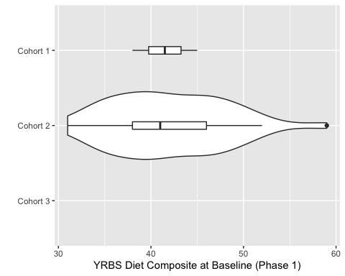

YRBS Physical Activity
Cohort 2 had a greater median physical activity score, and again had a larger spread (standard deviation) than Cohort 1. This suggests Cohort 2 is somewhat more active than Cohort 1.
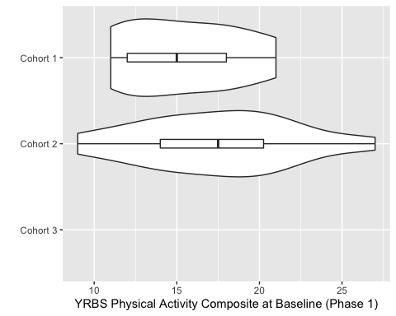

Self-Efficacy
Cohort 1 had a greater median self-efficacy score. Cohort 1 also had a much tighter distribution (smaller standard deviation) than Cohort 2. Note the positive and negative outliers in Cohort 2.
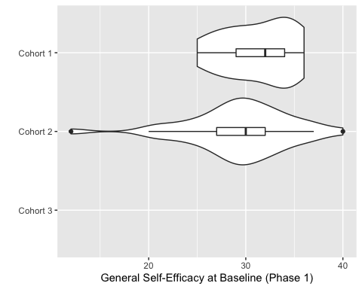

Empowerment

Composite Empowerment
Cohort 1 had a slightly greater median composite empowerment score than Cohort 2, and much less spread (smaller standard deviation).
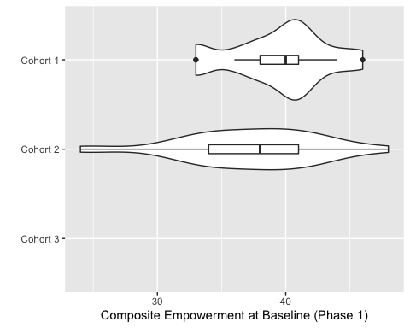

Individual Empowerment
Cohort 1 had a greater median individual empowerment score than Cohort 2. The standard deviation was greater for Cohort 2.
Note the median (50th percentile) and the first quartile (25th percentile) are overlapping for both cohorts. This is likely because the individual empowerment score is based on only 2 items, and therefore has much less possible variation. This increases the odds of individuals having the same scores, causing data sparsity issues, and making it impossible to make full boxplots without having more participants in each cohort.
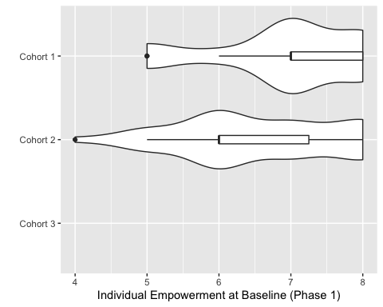

Community Empowerment
Cohort 1 had a greater community empowerment score, but only slightly. Cohort 2 had slightly greater spread (standard deviation).
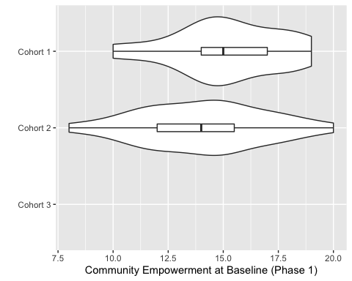

Organizational Empowerment
The cohorts had similar median scores for organizational empowerment. Cohort 2 was negatively skewed by an outlier. Note, the maximum possible score is 20 points for organizational empowerment; both cohorts are maxed out, suggesting a ceiling effect for this composite score. This suggests most participants have a high sense of empowerment in their organization (school).
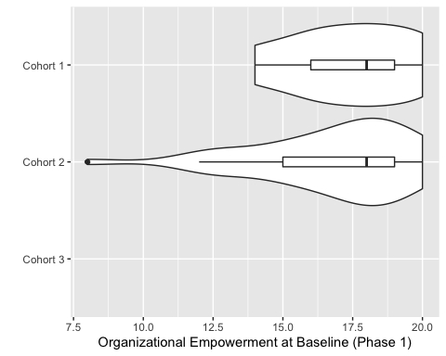

Anthropometric

Triceps Skinfold
The median triceps skinfold measurement was greater for Cohort 2. There were some positive outliers in this second cohort with much larger triceps skinfold measurements.
Note, these measurements are conditional on age (see table in section “Derived Anthropometric Variables”). However, the average age at Phase 1 were similar: 15.69 (0.48) for Cohort 1, and 15.30 (0.97) for Cohort 2 (see Table 1a). This suggests direct comparisons of anthropometric variables betweeen Cohorts 1 and 2 are reasonable, and Cohort 2 truly has greater triceps skinfold than Cohort 1, independent of normal growth in teenagers.
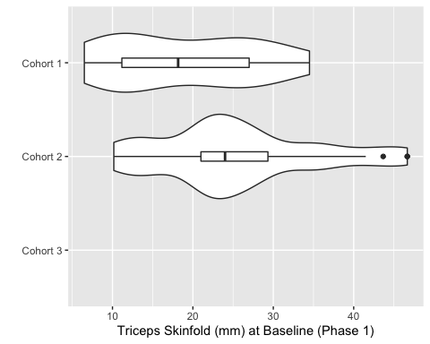

Waist Circumference
The median waist circumference was greater for Cohort 2. There were also several outliers with relatively large waist circumference measurements.
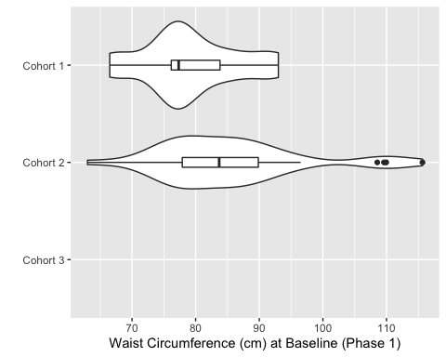

Longitudinal Data

Methods

Spaghetti Plots
Spaghetti plots can model longitudinal data over time. Each line represents an individual in the study. The line connects variable scores (YRBS Diet, Self-Efficacy, Triceps Skinfold, etc.) at each phase of the study. The thicker, red line represents the average score of all participants.
Note, some lines do not continue through all phases, indicating an individual who dropped out.
Individuals have been stratified by sex to explore changes in variable scores over time for male and female sex.

Cohort 1

YRBS

YRBS Diet
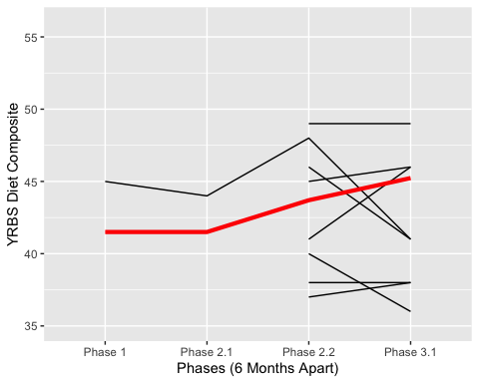

YRBS Diet by Sex
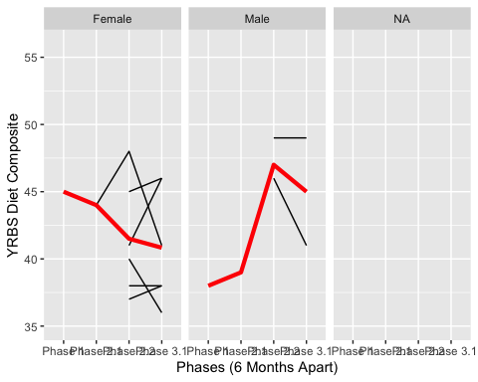

YRBS Physical Activity
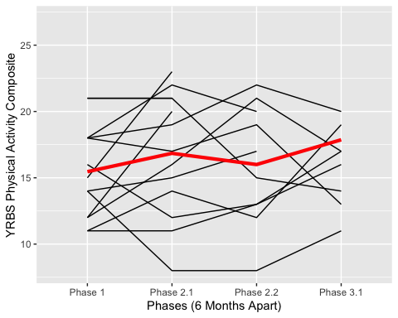

YRBS Physical Activity by Sex
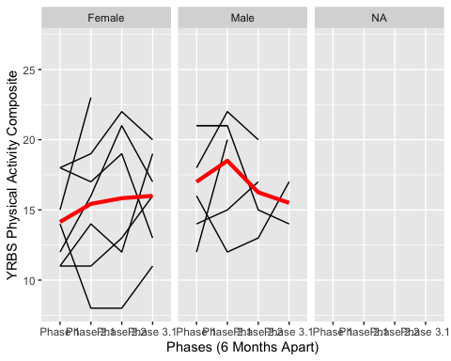

Self-Efficacy
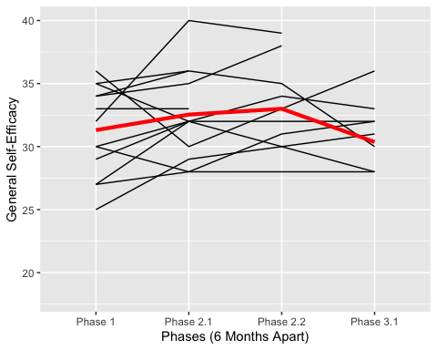

Self-Efficacy by Sex
## geom_path: Each group consists of only one observation. Do you need to
## adjust the group aesthetic?
## geom_path: Each group consists of only one observation. Do you need to
## adjust the group aesthetic?
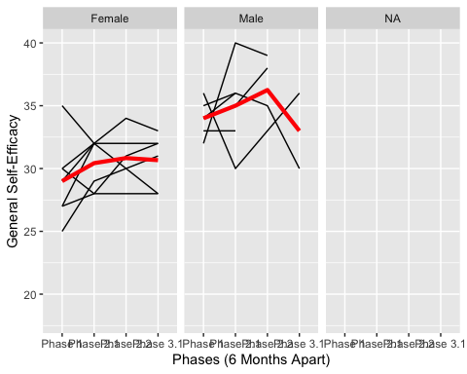

Empowerment

Composite Empowerment
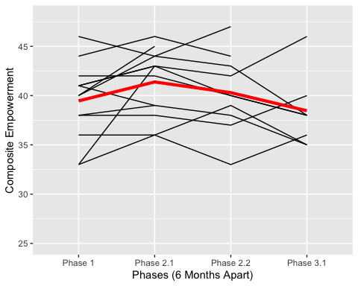

Composite Empowerment by Sex
## geom_path: Each group consists of only one observation. Do you need to
## adjust the group aesthetic?
## geom_path: Each group consists of only one observation. Do you need to
## adjust the group aesthetic?
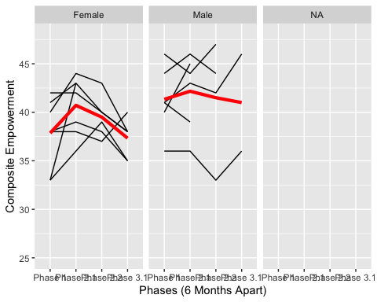

Individual Empowerment
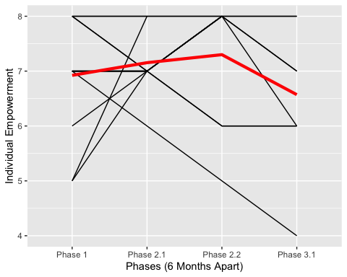

Individual Empowerment by Sex
## geom_path: Each group consists of only one observation. Do you need to
## adjust the group aesthetic?
## geom_path: Each group consists of only one observation. Do you need to
## adjust the group aesthetic?
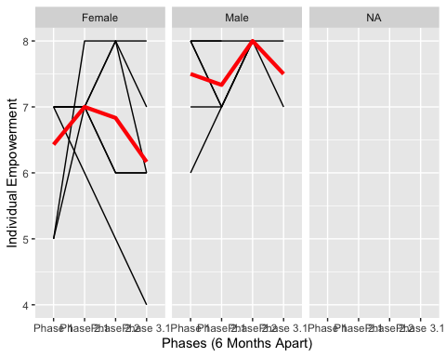

Community Empowerment
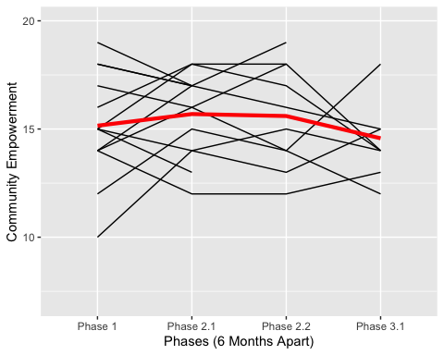

Community Empowerment by Sex
## geom_path: Each group consists of only one observation. Do you need to
## adjust the group aesthetic?
## geom_path: Each group consists of only one observation. Do you need to
## adjust the group aesthetic?
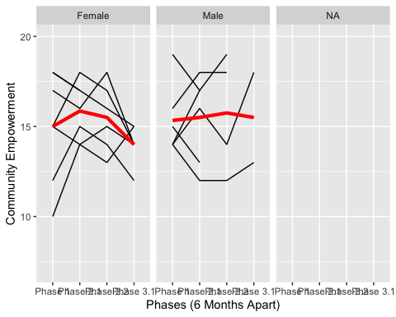

Organizational Empowerment
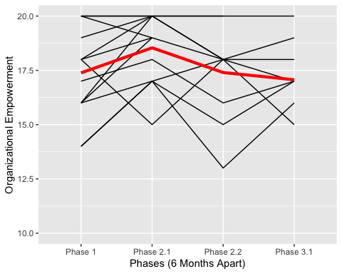

Organizational Empowerment by Sex
## geom_path: Each group consists of only one observation. Do you need to
## adjust the group aesthetic?
## geom_path: Each group consists of only one observation. Do you need to
## adjust the group aesthetic?
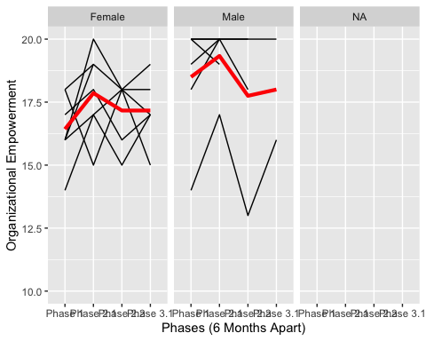

Anthropometric

Triceps Skinfold
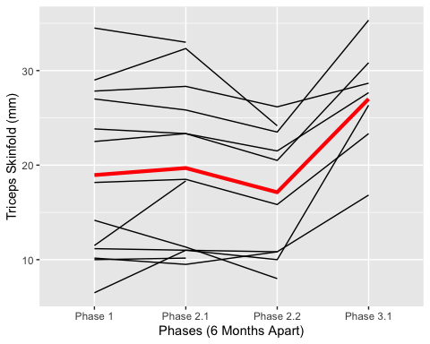

Triceps Skinfold by Sex
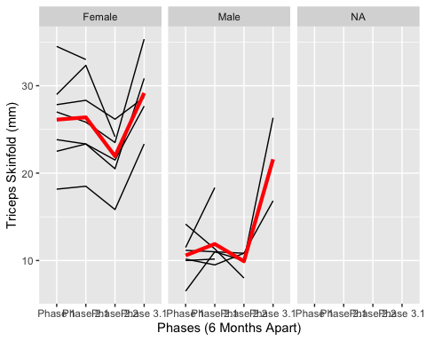

Waist Circumference
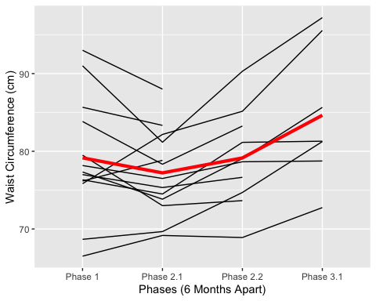

Waist Circumference by Sex
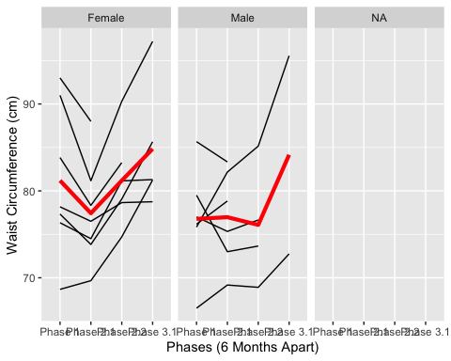

Cohort 2
Spaghetti plots for Cohort 2 cannot be created until data has been collecte for more than one phase.

Cohort 3
Spaghetti plots for Cohort 3 cannot be created until data has been collecte for more than one phase.

